

**<<TOPIC>> PROJECT REPORT**

**Software Requirement Specification**

– Ho Chi Minh, September 2025 –

Table of Contents

I. Record of Changes 3

II. Software Requirement Specification 4

1. Product vision 4

2. Product Overview 4

3. User Requirements 5

3.1 Actors 5

3.2 Use Cases 5

4. Functional Requirements 5

4.1 System Functional Overview 5

5. Use case details 6

5.1 Login 6

5.2 Filter Transaction 8

6. Non-Functional Requirements 10

6.1 External Interfaces 10

6.2 Quality Attributes 10

7. Requirement Appendix 10

7.1 Business Rules 10

7.2 Common Requirements 11

7.3 Application Messages List 11

7.4 Other Requirements… 11

# I. Record of Changes

|  |  |  |  |
| --- | --- | --- | --- |
| **Date** | **A* M, D** | **In charge** | **Change Description** |
| 30/6/2025 | A |  | Add context diagram |
| 2/7/2025 | A |  | Add use case diagram |
| 4/7/2025 | M |  | Edit use case diagram |
|  |  |  |  |
|  |  |  |  |
|  |  |  |  |
|  |  |  |  |
|  |  |  |  |
|  |  |  |  |
|  |  |  |  |

*A - Added M - Modified D - Deleted

# II. Software Requirement Specification

## 1. Product vision

A system to manage and monitor infertility treatment at a medical facility. The system supports the entire process from service registration, treatment management, progress monitoring to statistical reporting.

## 2. Product Overview

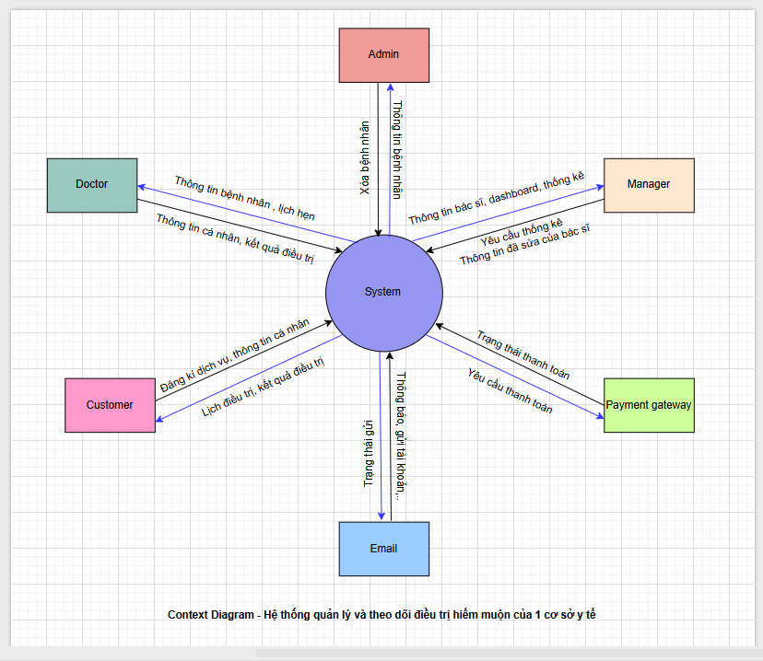

## 3. User Requirements

### 3.1 Actors

|  |  |  |
| --- | --- | --- |
| **#** | **Actor** | **Description** |
| **1** | **Guest** | Unregistered, limited access. |
| **2** | **Customer** | Registered users can schedule appointments, view their profile, track results, and treatment schedules. |
| **3** | **Doctor** | View customer(patient)’s information, view and edit medical record, and view appointment. |
| **4** | **Manager** | Operations management, reporting. |
| **5** | **Admin** | System administrator, full control |

### 3.2 Use Cases

#### 3.2.1 Diagram(s)

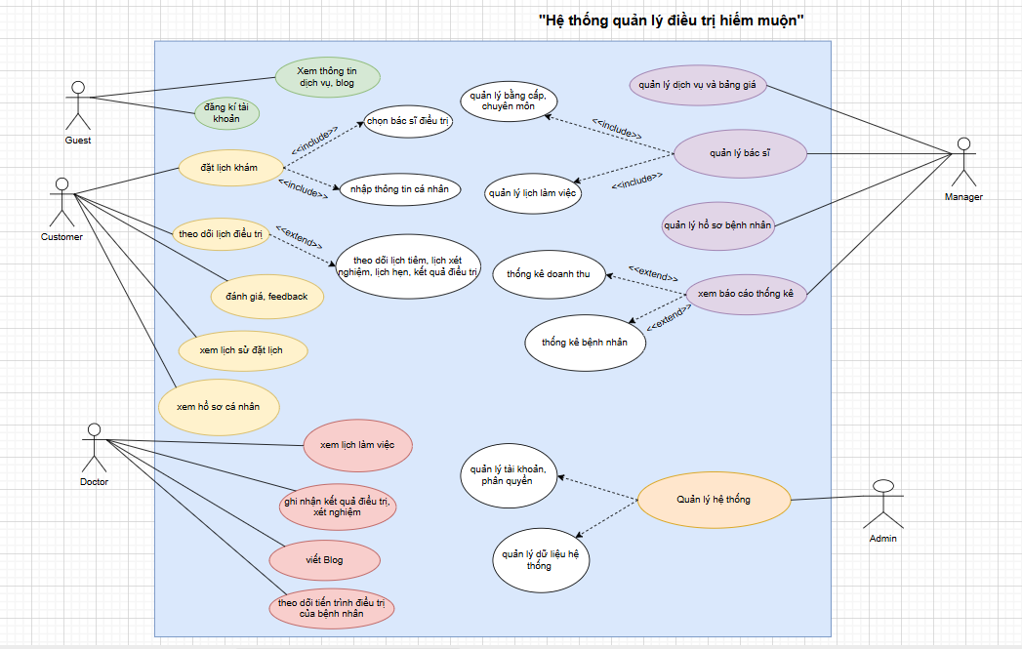

#### 3.2.2 Descriptions

|  |  |  |  |
| --- | --- | --- | --- |
| **ID** | **Use Case** | **Actors** | **Use Case Description** |
| *UC-01* | **Login** | **Customer, doctor,manager,admin** | **When actors login of the systems:**  **-Customers: view treatment step, treatment schedule, test result, profile**  **-Doctor: view and update customer’s medical record, accept booking of customer, write blogs and view schedule**  **-Manager: view list** |
| *UC-02* | *Logout* | *Admin, Teacher, Student, Guest* | *When actors logout of systems* |
| *UC-56* | *Filter videos* | *Admin* | *When actor want to find the videos by category include: name* |
| *UC-57* | *Filter course* | *Admin* | *When actor want to find the course by category include: name* |
| *UC-58* | *View List Courses* | *Teacher* | *When actor want to view list courses* |
| *UC-59* | *View List Videos* | *Teacher* | *When actor want to view list videos* |

## 4. Functional Requirements

### 4.1 System Functional Overview

#### 4.1.1 Screens Flow

#### 4.1.2 Screen Descriptions

*[Provide the descriptions for the screens in the Screens Flow above]*

|  |  |  |  |
| --- | --- | --- | --- |
| **#** | **Feature** | **Screen** | **Description** |
| *1* | *View fist courses* | *Home Page* | *View list courses* |
| *2* | *Search filter course* | *Home Page* | *Search by name or filter by category* |
| *3* | *Login* | *User Login* | *User logs into the system* |

#### 4.1.3 Screen Authorization

|  |  |  |  |  |
| --- | --- | --- | --- | --- |
| **Screen** | **Guest** | **Student** | **Teacher** | **Admin** |
| ***<<Home Page>>*** | *X* | *X* | *X* |  |
| *View Courses* |  |  | *X* | *X* |
| ***<<Login/Register Page>>*** | *X* |  | *X* |  |
| *Login* | *X* | *X* | *X* | *X* |
| *Register* | *X* |  |  |  |
| *Login by Google* | *X* | *X* | *X* | *X* |
| ***<<Student Profile Page >>*** |  | *X* |  |  |

#### 4.1.4 Non-Screen Functions

|  |  |  |  |
| --- | --- | --- | --- |
| **#** | **Feature** | **System Function** | **Description** |
| *1* | *Login with Google* | *Login* | *Users logs in the system with his Google account* |

#### 4.1.5 Entity Relationship Diagram

*<<ERD>>*

**Entities Description**

|  |  |  |
| --- | --- | --- |
| **#** | **Entity** | **Description** |
| *1* | *User Information* | *Contains user information include role, which permission user can perform* |
| *2* | *Transaction* | *Contains some form of recorded activity or interaction within the system, such as purchases, payments, or other operations* |
| *3* | *Submisstion* | *Contains data related to submissions, which could be assignments, forms, or other types of documents submitted by users.* |

## 5. Use case details

### 5.1 Login

|  |  |  |  |
| --- | --- | --- | --- |
| UC ID and Name: | **UC-01 Login** | | |
| *Primary Actor:* | *Guest, Student, Teacher, Admin* | *Secondary Actor:* | *N/A* |
| *Description* | *This use case allows actor login in College Exam Preparation Application* | | |
| *Goal* | *Define role for the actor (student, teacher, admin)* | | |
| *Trigger:* | *Actor click button "Login" from Home Page* | | |
| *Preconditions:* | *Connect to the system* | | |
| *Post-conditions:* | *Success: The actor is now logged into the system.*  *Fail: the system will send an error.* | | |
| *Normal Flow:* | |  |  |  | | --- | --- | --- | | ***Step*** | ***Actor Action*** | ***System Response*** | | *1* | *Actor click “login” on “home page”* | *System redirects to Login screen* | | *2* | *Actor fill all information include: username and password* | *System checks if the username and password has been authenticated in CEPA system yet*   * *Authenticated: System inform “Login success”, redirect to “home page” screen base on role* * *Unauthenticated: [Exception 1]* | | | |
| *Alternative Flows:* | |  |  |  | | --- | --- | --- | | ***Step*** | ***Actor Action*** | ***System Response*** | | *1* | *Actor click “login” on “home page”* | *System redirects to Login screen* | | *2* | *Actor click login with Google* | *System checks if the Google account has been authenticated in CEPA system yet*   * *Authenticated: System inform “Login success”, redirect to “home page” screen base on role* * *Unauthenticated: [Exception 2]* | | | |
| *Exceptions* | |  |  |  | | --- | --- | --- | | ***No*** | ***Cause*** | ***System Response*** | | *1* | *Actor fill invalid information* | *System inform “username or password incorrect please try again”* | | *2* | *Google account not exist in system* | *System inform “account not exist please try again”* | | | |
| *Priority* | *High* | | |
| *Frequency* | *Guest want to login to CEPA system* | | |
| *Business Rules* | *N/A* | | |
| *Mockup* |  | | |

### 5.2 Filter Transaction

|  |  |  |  |
| --- | --- | --- | --- |
| UC ID and Name: | **UC-02 Filter Transaction** | | |
| *Primary Actor:* | *Teacher* | *Secondary Actor:* | *N/A* |
| *Description* | *This use case allows teachers to filter financial transactions related to their courses.* | | |
| *Goal* | *Filter financial transactions.* | | |
| *Trigger:* | *Teacher selects the "search" option.* | | |
| *Preconditions:* | *Teacher is logged into the system, has created courses, and wants to filter transaction information.* | | |
| *Post-conditions:* | *Teacher views filtered financial transaction information related to their courses.* | | |
| *Normal Flow:* | |  |  |  | | --- | --- | --- | | ***Step*** | ***Actor Action*** | ***System Response*** | | *1* | *Actor click “transaction” on “sidebar”* | *System redirects to “Transaction” screen and show list of transaction* | | *2* | *Actor write on search bar or choose type to filter transaction* | *System base on information and type to filter transaction*  *[Exception 1]* | | | |
| *Alternative Flows:* | *N/A* | | |
| *Exceptions* | |  |  |  | | --- | --- | --- | | ***No*** | ***Cause*** | ***System Response*** | | *1* | *Empty transaction* | *System inform “Transaction is empty”* | | | |
| *Priority* | *High* | | |
| *Frequency* | *Teachers may filter transaction information for their courses as needed.* | | |
| *Business Rules* | *N/A* | | |
| *Mockup* |  | | |

## 6. Non-Functional Requirements

### 6.1 External Interfaces

*[This section provides information to ensure that the system will communicate properly with users and with external hardware or software/system elements.]*

#### 6.1.1 User Interface

1. *User friendly interface*

#### 6.1.2 Hardware Interface

* No hardware interfaces have been identified

### 6.2 Quality Attributes

#### 6.2.1 Usability

* *All text, label and message should be uniformly written in Vietnamese.*

#### 6.2.2 Reliability

* *Bugs or Defect Rate: Warning 1%, Critical: 0.05%*

#### 6.2.3 Performance

* *Response time for a transaction (average, maximum): (1.16s, 1.16s)*

## 7. Requirement Appendix

### 7.1 Business Rules

|  |  |
| --- | --- |
| **ID** | **Rule Definition** |
| *BR-01* | *Teacher do not possess the authority to delete videos or course resources from the system. Instead, they retain the capability to conceal videos.* |
| *BR-02* | *Admin account only provided by system* |
| *BR-03* |  |

### 7.2 Common Requirements

1. *Data in the form of lists, tables, etc. will be displayed as data tables/paging supported*
2. *All changes, updates, and modifications are alerted by pop-up*
3. *Supports PNG, JPG, JPEG image file format , maximum image size 10MB*

### 7.3 Application Messages List

|  |  |  |  |  |
| --- | --- | --- | --- | --- |
| **#** | **Message code** | **Message Type** | **Context** | **Content** |
| *1* | *MSG01* | *In line* | *There is not any search result* | *No search results.* |
| *2* | *MSG02* | *In red, under the text box* | *Input-required fields are empty* | *The * field is required.* |
| *3* | *MSG03* | *Toast message* | *Updating asset(s) information successfully* | *Update asset(s) successfully.* |
| *4* | *MSG04* | *Toast message* | *Adding new asset successfully* | *Add asset successfully.* |

### 7.4 Other Requirements…

* N/A